Table of Contents

Introduction 3
- Strategic considerations 4
- Design recommendations 5
- Content recommendations 9
- Advanced features 14
- Conclusion 16

Appendix 1:

Internet search results assessed for 11 leading search engines 17

Appendix 2:

Relevant corporate Web sites compared 19

I. INTRODUCTION

A locally established company with quality sites in its portfolio designed (undisclosed client) Web site. However, this review recommends a redesign of the site. In doing so, it focuses on the user experience in the context of the supposed Internet strategy of the company. It prioritises clarity as a design objective and discourages the use of unnecessary features.

The (client brand site) and (client subsidiary) sites are not reviewed here because they feature different and more effective interfaces as well as better content. There should be consistency in quality and–if in accordance with marketing strategy–in style between the three sites.

The recommendations contained herein for the most part exclude references to specific design tools like Flash, html, and Java. The company and designers should jointly decide which tools to employ in accordance to financial and technical imperatives.

It is assumed that, in the near future, (client) will neither (a) offer products which can be delivered over the Internet nor (b) operate a portal service carrying third-party banner advertising. If these assumptions are correct, the company’s Internet requirements are straightforward.

The design philosophy behind this review is similar to that of (undisclosed corporate Internet consultants). The company’s own site serves as a showcase of good design, especially as concerns the presentation of text.

II. STRATEGIC CONSIDERATIONS

As great as it may be for other types of information sharing and dissemination, the Internet remains a mediocre marketing tool in general, and for luxury real estate brands in particular. In Europe, this will not change for a few years, or until high bandwidth is truly widespread and Internet connections become as common as telephone lines and televisions in the homes of the older generations of consumers. Statistics show that Internet take-up in the US will soon reach this level. Nevertheless, there are at least four arguments to support the case for a high quality corporate Web site for (client) even before this sea change:

- Limitations of hit rates as a measure of effectiveness

Just like a high hit rate can become a liability–for instance if a Web address is advertised extensively in print and the site is poor–a good site may be relatively rarely visited but still constitute a powerful element of the corporate image. Even if they are few, those that do visit the site will share their general impressions about the company with others. The typical visitor to the site of a company dedicated to luxury real estate will not only command substantial professional or personal financial resources but also be intelligent, energetic and most importantly active in the modern economy. Such an individual is likely to be influential and therefore to help spread the word, good or bad, about the company.

- Preparing for greater bandwidth

Savvy investors who stayed out of the frenzy of over-investment toward all things Internet five years ago also refrained from going to the other extreme by giving up on the technology simply because the bubble burst. Fast, pleasurable, and widespread 'surfing' as well as the commercial coming of age of the Internet are just a question of time. Companies that maintain a streamlined Web presence up to that point will be better prepared to take up the opportunity when this happens.

- Quality design at low cost

Just as a gifted young student can produce an outstanding site for a small fee, established companies charging thousands of euros routinely produce poor sites. Designers often lack design skills, programming skills, an adequate understanding of business in general, and/or an adequate understanding of their clients’ businesses in particular. Conversely, company staff responsible for outsourcing Web design work must have a basic understanding of the technological and design alternatives that designers will offer. Creating an informed specification in-house before outside designers are approached reduces the design company’s workload and the fee that it can charge as well as the scope for misunderstandings or disputes.

- Rising standards

Although most Web sites are poor, an increasing number of successful large and small companies have moderately effective to effective sites. Even ‘technophobes’ are finding the Internet increasingly useful, and this group of users will be the first to remember how easy or difficult it was to navigate a site.

- imagery for the press
Photography and graphics should be archived and downloadable in a high-resolution printable format. Each photo or graphic should have (a) a name (e.g. file name), (b) a date of issue (can be part of file name), a suggested descriptive caption, and a copyright note. The archive does not need to be limited to imagery issued with particular press releases.

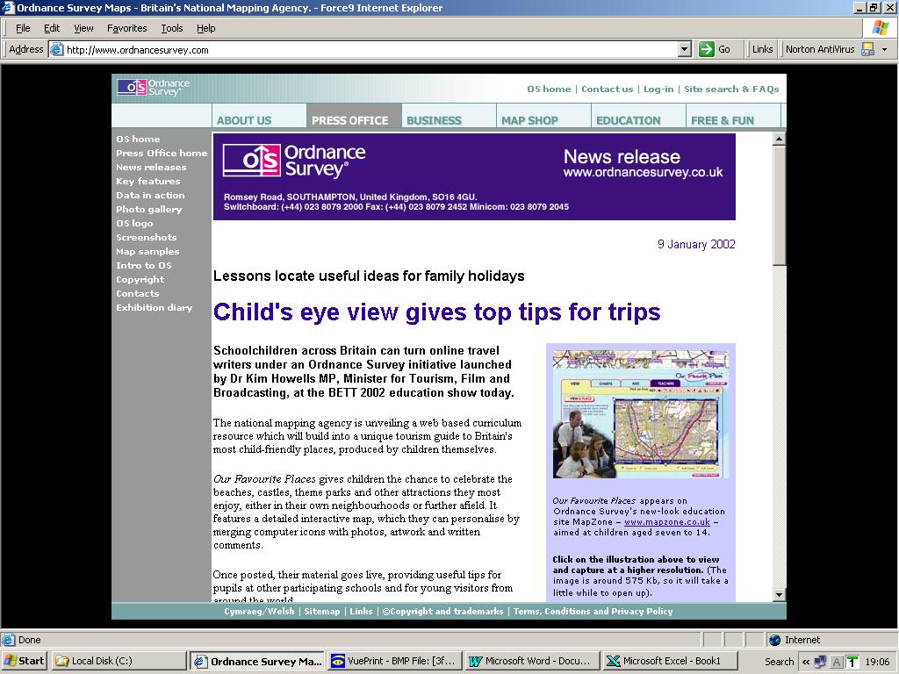

fig. 3: UK national mapping agency the Ordnance Survey boasts a beneficial relationship with the press despite ongoing sensitive issues concerning public domain data dissemination and the partial privatisation of the agency. A complete archive of press releases and imagery as well as other resources is provided on the agency’s Web site. In addition, photos linked to individual releases are visible in thumbnail form on the release page, with an option to view and download a high-resolution printable version. A horizontal navigation area for the entire site and a vertical one for the press section are featured. (screenshot platform as fig. 1)

VI. CONCLUSION

Commercial Web sites function as one or more of the following: (1) a vehicle for third-party advertising, (2) an e-commerce facility for the company’s products, (3) a source of public product and corporate information for customers, investors, partners, and the press. The architecture of the (client) site should be suited exclusively to the third function, which is the simplest and least expensive of the three to implement.

If a complete redesign is carried out, the hallmarks of the streamlined site should be:

- striking clarity both in aesthetic design and content
- compliance with and strategic use of Microsoft and Apple standards
- clear and up-to-date content that is comprehensive yet concise
- easy internal updateability by authorised non-technical staff
- stunning photography
- fast-loading times
- classic type styles that do not distract from corporate logos and styles
- the absence of unnecessary functionality

If full redesign is not an option at this time, the current site would greatly benefit from a number of urgent or easy changes:

- elimination of the ‘pirate’ interface described in section III, 1
- a quick redesign of the entry-point homepage in accordance to some of the ideas outlined in section III, 4, a and IV, 1
- a number of spelling errors and minor glitches are also listed in section IV, 4

 |  | SEARCH TERM (multiple words entered as phrases)
 |  | (undis-closed) | (undis-closed) | (undis-closed) | (undis-closed) | (undis-closed) | (undis-closed) | (undis-closed) | (undis-closed) | (undis-closed) | (undis-closed) | (undis-closed)
SEARCH ENGINE | Alltheweb | 5 | 1 | 1 | None | none/  none | none | none | none | 8 | 1 | none
SEARCH ENGINE | AltaVista | 4 | 1 | 3 | none (undisclosed: 3) | 1/none | none | none | none | none | 1 | none
SEARCH ENGINE | Ask Jeeves | 8 | 1 | 2 | None | none/  none | none | none | none | 1 | 1 | none
SEARCH ENGINE | Dogpile | 9 | 1 | 1 | None | 1/none | none | none | none | 25 | 16 | none
SEARCH ENGINE | Excite | 2 | 1 | 1 | None | 1/none | none | 3 | none | 19 | 5 | none
SEARCH ENGINE | Google | 9 | 1 | 1 | none  (undisclosed: 6) | 1/none | none | 1 | none | none | none | none
SEARCH ENGINE | Hotbot (Lycos) | 10 | 1 | 1 | None | none/  none | none | none | none | none | none | none
SEARCH ENGINE | Infoseek (Go) | 10 | 1 | 1 | None | 1/none | none | 4 | none | none | none | none
SEARCH ENGINE | LookSmart | 10 | 1 | 1 | None | none/  none | none | none | none | none | 11 | none
SEARCH ENGINE | Metacrawler | 2 | 1 | 2 | None | 1/none | none | 4 | none | none | none | none
SEARCH ENGINE | Yahoo | 7 | 1 | 1 | None | none/  none | none | 2 | none | none | 12 | none
¹ Whether entering the term ‘(client)’ should yield links to (undisclosed) is at the discretion of the company. The search presently delivers results with links to many (undisclosed) sites and, in some cases, to the (client subsidiary) site.
² For ‘(client subsidiary)’ it is the subsidiary’s own site that should have prominence within the results. Two rankings are therefore included: first, that of the (client subsidiary) site and second, that of (client) site.
³ There are many companies world-wide called (undisclosed), hence the lack of any results leading directly to the (client) site, but this can be remedied.

